**BEST PRACTICE – 1**

**(2023-24)**

**PROGRAM ON AWARENESS AND RALLY AGAINST DRUG ABUSE AND ILLICIT TRAFFICKING – SAY NO TO DRUGS**

1. **GOAL:** To create awareness against drugs and to avoid its use by the youth especially including the public for pleasure or other psychological reasons.
2. **THE CONTEXT:**The students were given proper training to involve in rally program form its inception from the college and to the surrounding neighboring areas to create awareness to the door to door public through their displays and slogans and banners.
3. **THE PRACTICE:**
4. Around 300 students who were interested to create awareness to public were given proper training regarding on “ slogans, display cards, banners handling and conveying to public”.
5. The program was initiated by Mr.V.N.K.Chaitanya, Deputy superintendent of police, Rajampet, Annamaiah Dist.
6. The police team, college management, Principal of college, along the faculty team participated in the pledge program on the oath said by D.S.P.
7. Then the students with police and faculty team incepted the rally program from the college with the banner “ SAY NO TO DRUGS”
8. This program was carried by the students as most of the youth are addicted to drugs in now days due to pleasure or psychological feelings, or maintaining bad friends or communicating with mentally disturbed or youth damaged people
9. It not only spoils education but also damages the health which could one day leads to addiction.
10. The drugs used by the youth causes serious damages to the public and their family and career.
11. Serious road accidents, suicides, murders, acid attacks has been done or involved either directly or indirectly by the users with or with out their knowledge.
12. The students travelled around 3 kilometers and penetrated to public on the main road to say the adverse effects caused by the harmful drugs.
13. The public also received well performance by the rally and called by the public to take care of their children and to inform to police or physician for better counseling to avoid its usage.
14. **EVIDENCE OF SUCCESS**

The public got good awareness on the program theme say no to harmful drugs, as it causes serious adverse effects to health, career and their family and surrounding in neighborhood. They know the new methods of solutions by the rally awareness to council the addicted youth or public. The public were also given suggestions on the use of it causes with or with out human conscious many untoward activities will be carried if not arrested or eradicated the use of abuse drugs.

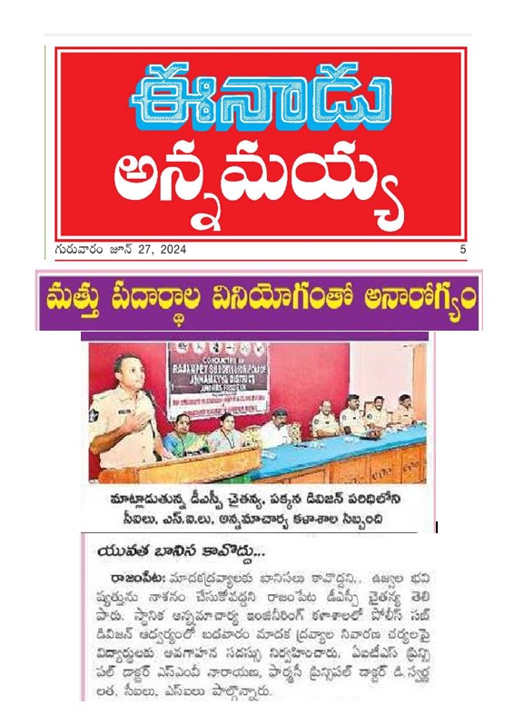

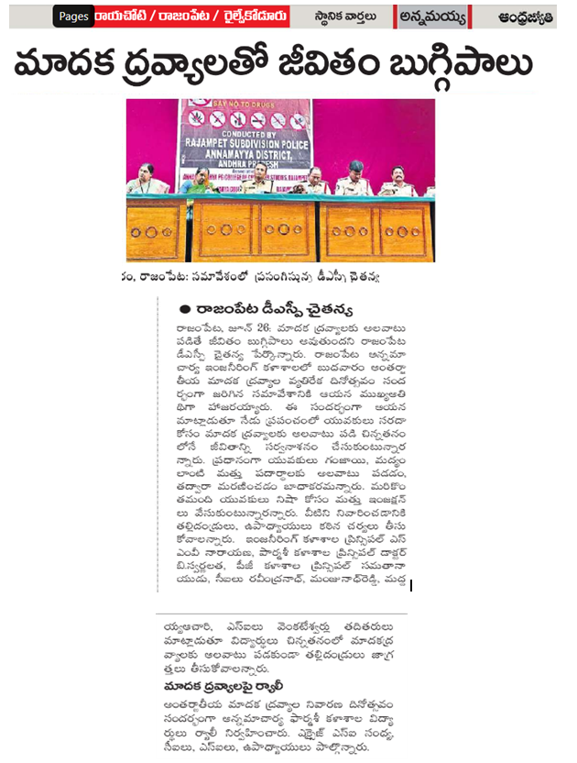

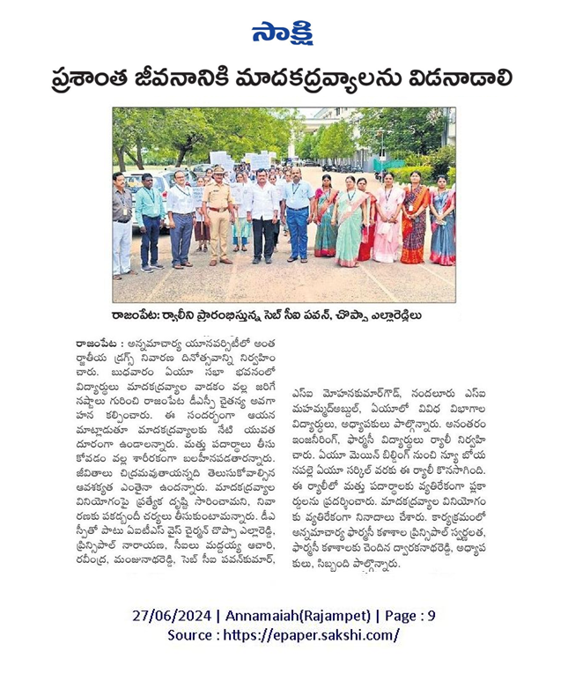

**Mr. VNK.Chaitanya, Deputy Superintendent of Police, the chief guest adressing and speaking on the program.**

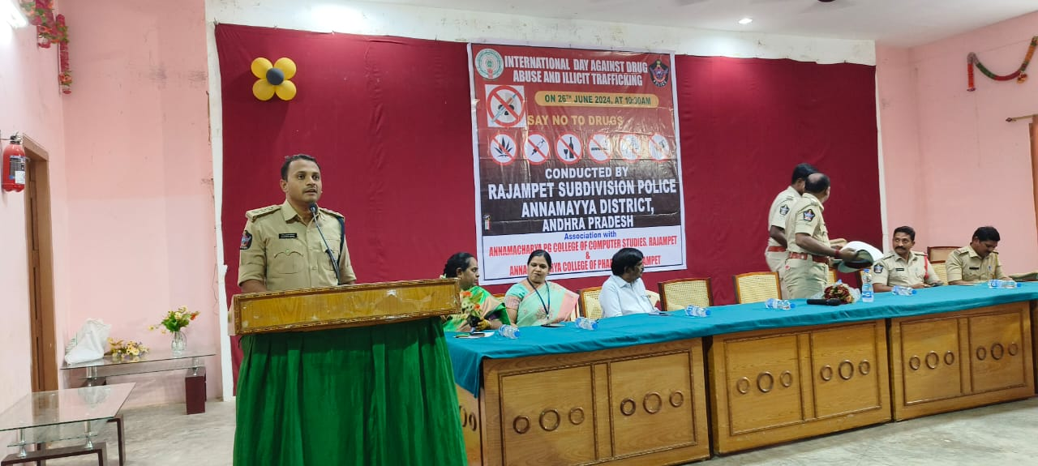

**The management, principal, guests, staff and students gathered to participate in the program**

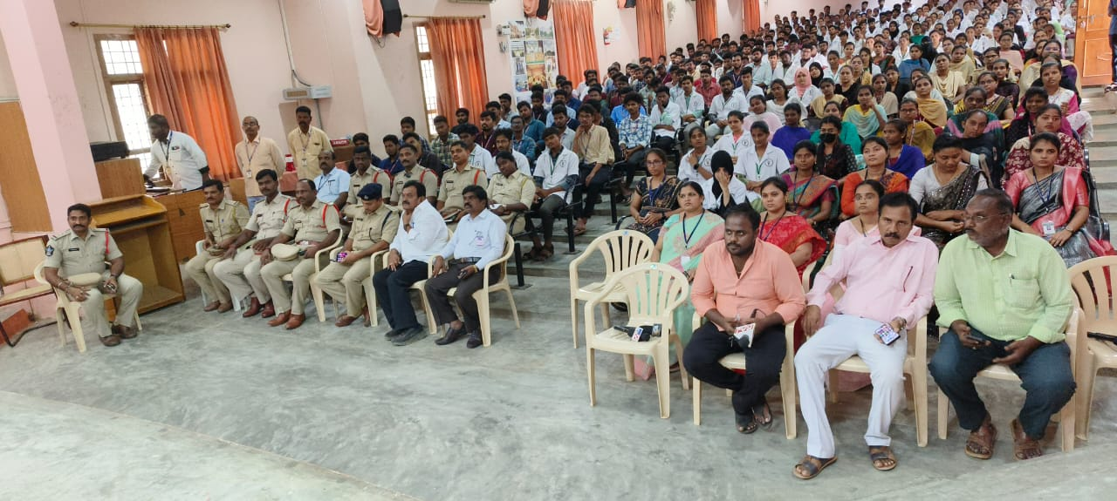

**The participants taking oath on drug abuse by the police department**

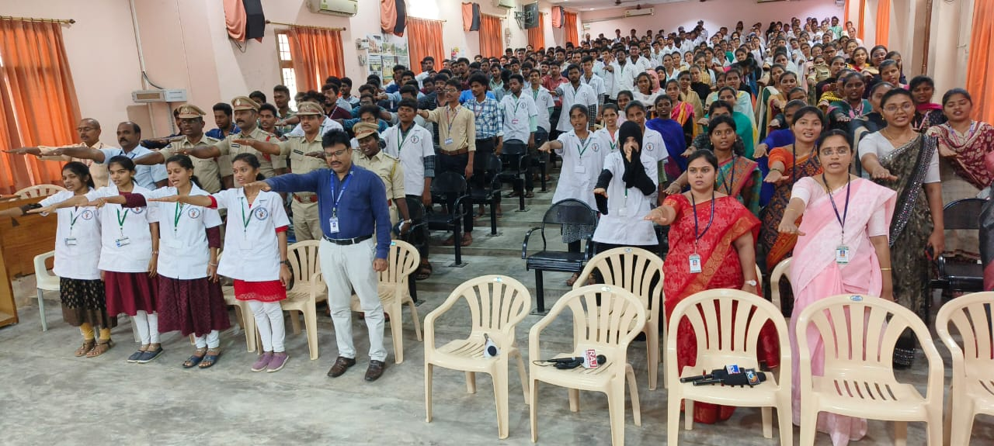

**All the arrangements before the rally program on “Say No To Drugs”**

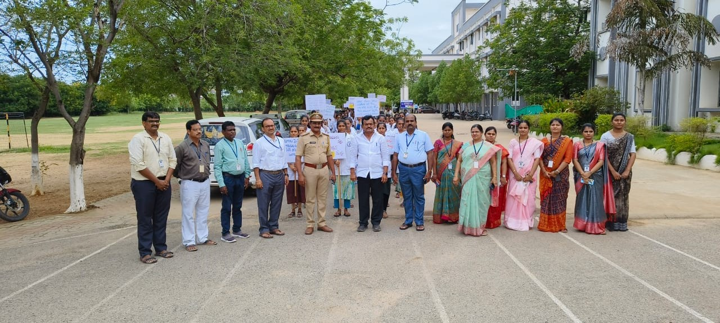

**Inception of the rally program in the ANCP campus** 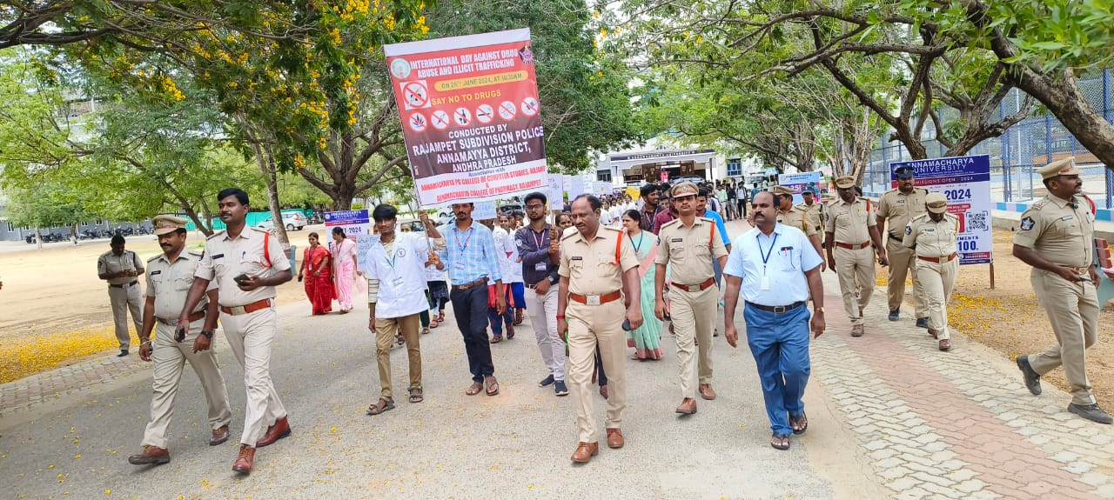

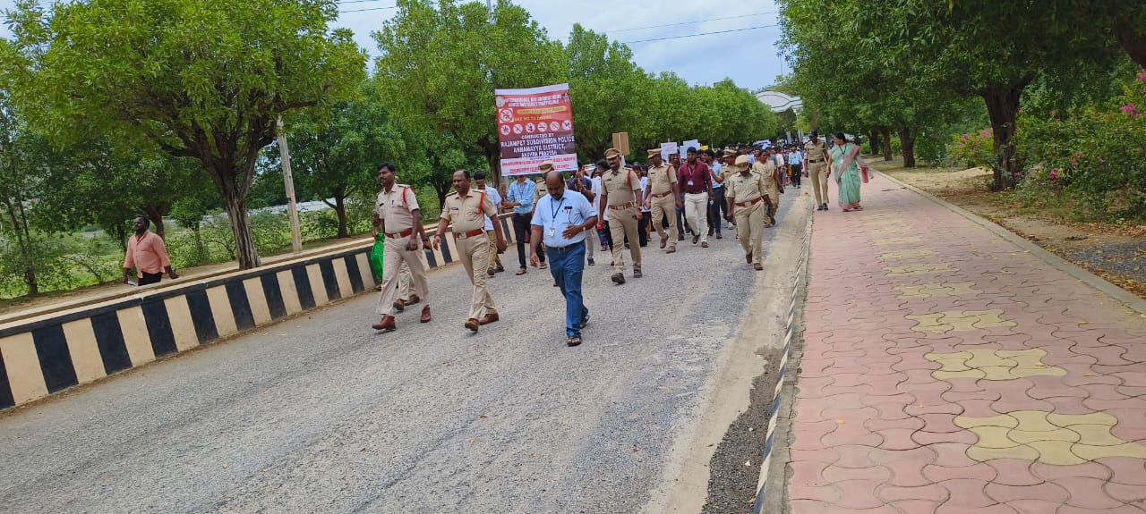

**The girl students actively participated in the program**

